COM161 Problem Solving for Computing Practical Lab
Practical Lab 4
The tasks below are based on the gap notes entitled Repetition Structures. In a number of cases, you are directed to programs on Blackboard. In each case, you should save a copy of the code to your own folder before editing.

1. A copy of commission.py, which was used as an example in the notes, is available on Blackboard.
(a) Feedback has been obtained from the users that when they accidentally enter Y as opposed to y the program exits. Modify the code to allow the program to keep running when a user enters ‘y’ or ‘Y’.
(b) The management has introduced a new strategy to increase performance amongst its sales staff. If the salesperson manages to make sales of more than £5000 they get an extra £50 bonus added to their commission. Modify the code to automatically add this to the overall commission calculated.

2. A copy of squares.py, which was used as an example in the notes, is available on Blackboard.
(a) Modify the code so that it prints out the first 20 squares and cubes.
(b) The code prints the numbers 1 to 20 and their squares and cubes. Modify it further to allow the user to specify the largest number that should be used.

3. A copy of the program sum_numbers.py is available on Blackboard. It currently reads in 5 numbers and calculates the total. Note that two key points of the code are that the variable total is initialised to 0 at the beginning of the code, and at each iteration of the loop total is updated via
total = total + number
This is a standard technique for calculating a running total of numbers.
Modify the code to
(a) Allow the user to specify how many numbers s/he is going to enter.
(b) Display both the final total and the average of the numbers.

4. In science and technology we frequently end up with very big and very small numbers. To help us with this we use prefixes for multiples. These are usually in powers of 3.
Multple | Prefix | Symbol | Submultiple | Prefix | Symbol
10³ | kilo | K | 10⁻³ | milli | m
10⁶ | mega | M | 10⁻⁶ | micro | µ
10⁹ | giga | G | 10⁻⁹ | nano | n
10¹² | tera | T | 10⁻¹² | pico | p

Thus, 1000 metres is 10³ metres, or 1 kilometre, or 0.000001 seconds is 10⁻⁶ seconds, or 1 microsecond. Using powers of 10 to represent large or small numbers is called scientific notation and Python accepts such notation using ‘e’.
Thus entering 1e3 in the interactive mode returns 1000.0 or
1.2e-4 will return 0.00012. We can also format output. For example check what format(1244.23, 'e') and format(1244.23, '.2e')return.
In the late 1980s and 1990s, a standard way to save and transfer data was to use a floppy disc. A floppy could hold 1.44MB of data and was about 10 by 10 cm and 3.2 mm thick. How many 1.44MB floppy discs would you need to have the same storage capacity as a 1TB pen drive? If they were piled on top of each other, how high would the pile be?
5. The program square_v2.py on Blackboard uses a simple loop to draw a square of side 100. The code uses the idea that at each iteration of the loop the turtle turns through 90º (=360º/4). In general, to create a regular polygon of n sides the turtle should turn through 360º/n at each iteration. Using this idea, write a Python code that draws a regular polygon of n sides, where n is specified by the user.

6. Well, Mark McCartney is very pleased with himself. After last week’s incident with his boss, he has finally written a Python program that actually works. It took him 3 hours, a pot of coffee, and a whole packet of chocolate digestives, but still. So pleased is he with himself that he has declared the code itself ‘a masterpiece’ and is currently trying to patent the algorithm. As such he refuses to reveal the code but is running around the office showing off the graphical output of the code (below) and challenging his colleagues to reproduce it. All he is willing to say is that there are 36 squares in the output. None of his colleagues were available to comment. Well, they were actually, but most of what they said was so derogatory that it can’t be published.
Can you put young McCartney in his place by writing some Python to reproduce his image? And perhaps write a code that will allow the user to specify how many squares should be drawn?
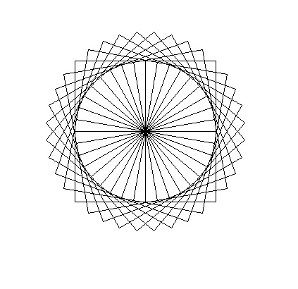
7. A prime number is an integer that is exactly divisible by only itself and 1. A brute force method to evaluate whether a given number, N, is a prime is to check that it is not exactly divisible by any number between 2 and the largest integer less than. Write a program that asks the user for an integer and then returns whether it is an integer or not. Is 77777677777 a prime number?

